Zomato Final Analysis Report
By: Ansh Jain
jainanshhhm@gmail.com
: Objective Questions
Q1. What is the total no. of tables present in the data ?
- There are 2 sheets with one table each: Restaurants Data and Country Description
Q2. What is the total no. of attributes present in the data?
- After adding the required columns (Opening Year, Custom price, (INR)Average_Cost_for_two,Country)
- In raw data – 24 attributes
- Country description – 2 attributes
Q3. How many categorical columns are there in the data? [Search about categorical and continuous data, and try to answer this question]
In Raw Data 15 columns
- Restaurant Name
- Country Code
- City
- Address
- Locality
- Locality Verbose
- Cuisines
- Currency
- Has Table booking
- Has Online delivery
- Is delivering now
- Switch to order menu
- Price range
- Rating
- Year (Newly added)
In Country description 2 columns
- Country Code
- Country Name

Q4. The data consists of some inconsistent and missing values so ensure that the data used for further analysis is cleaned.?
- No duplicate values are found in the dataset.

There are some inconsistencies in “Cuisines”, “City” and “average cost of two” .
- Cuisines : In ‘Cuisines’ column 9 blank entries were found and which were removed to maintain the integrity of the data set.
- City: By reviewing the data , I found the spelling mistakes in few cities name , the I used find and replace function to correct all those mistakes/errors for better data quality .
By using find and Replace

Sí£o Paulo → São Paulo,
Brasí_lia → Brasilia,
ÛÁstanbul → Istanbul,
Rest of Hawaii → Hawaii,
Mc Millan → McMillan,
Vizag → Visakhapatnam.

- “0” entries (Average Cost of Two) : The Average Cost for Two column had some entries with a value of “0” (for country India and United States of America). Then I calculated the average of Average cost for two for the specific country and replace the “0” entries with that average, so that the Data will be consisted and error less.
For India average was – Rs.623.37
For United States of America average was - $26.35
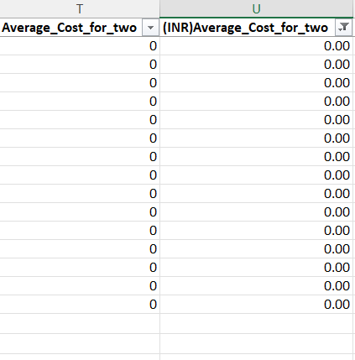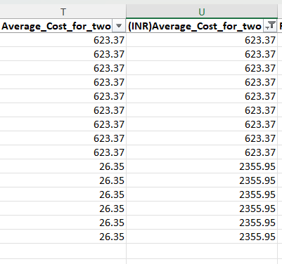

Average cost of Two(INR):For analyzing the data it is necessary that the variable value should be in same unit so I have converted all the Currency amounts into INR. First, I had created a new table in a sheet named “Exchange rate” which contain the exchange rates of different currencies into INR then using XLOOKUP function converted all the values into INR.
Formula: T2*XLOOKUP(L2,'Exchange rate'!$A$2:$A$13,'Exchange rate'!$C$2:$C$13)

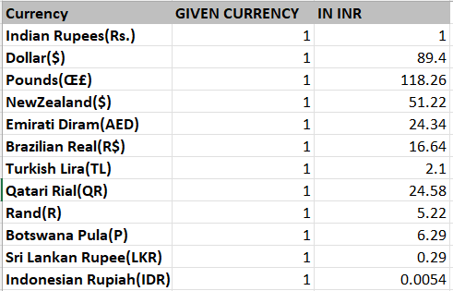

Q5. Using the LookUp functions, fill up the countries in the original data using the country code.?
- Used VLOOKUP to populate country names from the Country Code.
- Formula Used : =VLOOKUP(C2,'country description'!$A$1:$B$16,2)

Q6. Create a table to represent the number of restaurants opened in each country.?
- Using Pivot Table
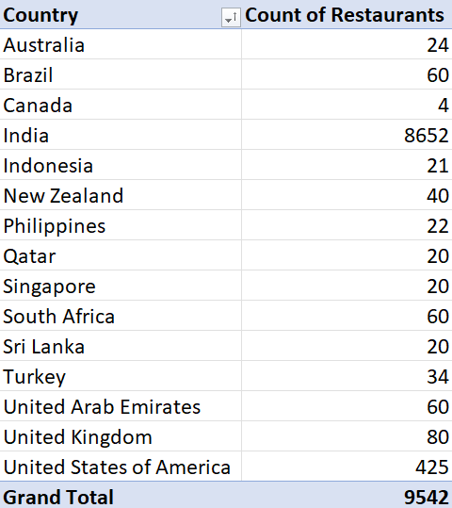
Q7. Also, the management wants to look at the number of restaurants opened each year, so provide them with something here.?
- Using Pivot Table
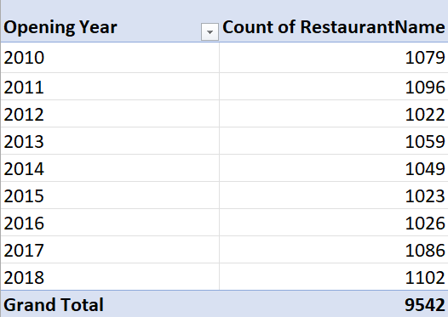

Q8. What is the total number of restaurants in India in the price range of 4?
Count of Restaurants = 388
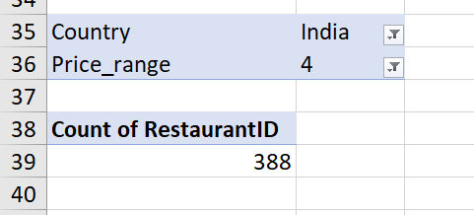
- In sheet named “Descriptive Data”
Q9. What is the average number of voters for the restaurants in each country according to the data?
- In sheet named “Descriptive Data”
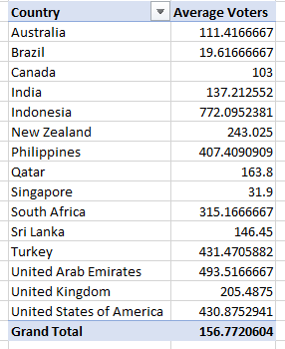

Q10. Calculate the average rating for all the restaurants that have price_range < 4 and provide online delivery. Use only the “IF” function, Logical Operators, and Aggregation functions to solve this problem. [Note: Don’t use Conditional aggregation in this question.]?

- Formula used: =AVERAGE(IF(('Raw Data'!Q2:Q9543<4) * ('Raw Data'!N2:N9543="Yes"),'Raw Data'!V2:V9543))
- In sheet named “Descriptive Data”

Q11. Using Conditional formatting highlight the rows of restaurants that are located in the countries or cities that you’ve suggested to the management for opening new restaurants.?

Used conditional formatting to highlight the rows with the restaurants present in the country which I suggested for opening of new restaurants.

- Criteria for Selection:

- Medium Competition: It means that no. of restaurants should not be much in that area but the demand is enough for the new restaurant.

- Customer satisfaction Rate: High average rating suggests that customers are liking the quality of facilities provided by the restaurants of that country/city/area.
“Average Cost for Two (INR)” helps assess affordability and expected expenditure; moderate pricing indicates potential for new entrants

- Factors that influenced my choices :

““The Philippines and Indonesia stand out as high-efficiency markets; the Philippines boasts the highest average rating (4.47) among the four, despite a relatively moderate cost, suggesting a consumer base that deeply appreciates quality and provides strong word-of-mouth potential. New Zealand offers the benefit of scale, supporting the largest number of restaurants (40) while maintaining a solid 4.26 rating, indicating a stable and mature market capable of sustaining high volume. Meanwhile, Qatar represents the premium luxury segment; although it has a slight lower average rating (4.06) , its exceptionally high average cost of ₹5,499.75 points to a high-margin environment with significant "white space" to capture the market by introducing superior service standards. Together, these locations allow a brand to diversify across high-growth emerging markets and high-value established economies.””

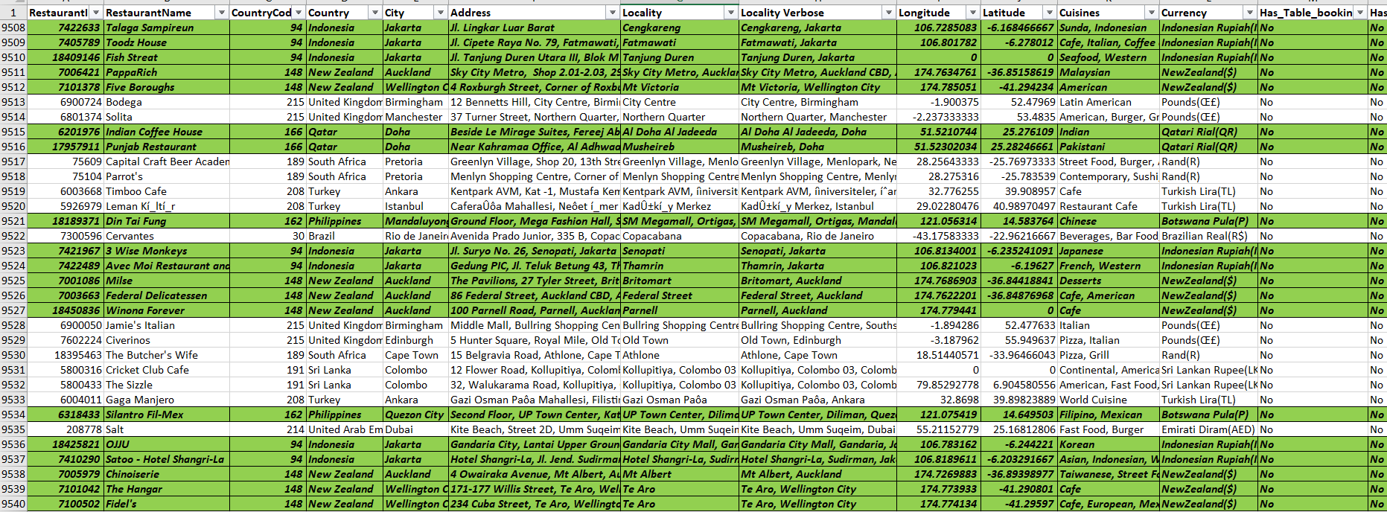

- Reference: in the sheet named “Raw Data”

Q12. Create a new customized price column that consists of the abbreviation/symbol of the currency along with the Average_cost_for_two value. [Use string operations to do this task]?
- Custom Price
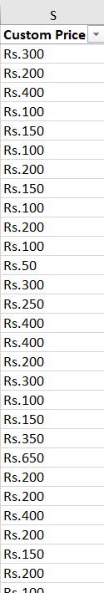

Q13. Count restaurants not offering online delivery, lowest price range, avg cost ≤ 250 INR:
- Restaurant: 1676

- Formula used: =COUNTIFS('Raw Data'!N:N,"No",'Raw Data'!Q:Q,1,'Raw Data'!U:U,"<=250")

- In sheet named “Descriptive Data”

Subjective Questions:

Q1. Suggest a few countries where the team can open newer restaurants with lesser competition. Which visualization/technique will you use here to justify the suggestions?

- Criteria for Selection:

- Medium Competition: It means that no. of restaurants should not be much in that area but the demand is enough for the new restaurant.
- Customer satisfaction Rate: High average rating suggests that customers are liking the quality of facilities provided by the restaurants of that country/city/area.
“Average Cost for Two (INR)” helps assess affordability and expected expenditure; moderate pricing indicates potential for new entrants.

On the basis of above-described criteria the countries selected are: Indonesia, Philippines, New Zealand, Turkey

- Indonesia: 21 restaurants, Average Rating 4.30, Average Cost ₹1,518.74
- Philippines: 22 restaurants, Average Rating 4.47, Average Cost ₹2,458.43

- New Zealand: 40 restaurants, Average Rating 4.26, Average Cost ₹3,572.59
- Qatar: 20 restaurant, Average Rating 4.06, Average Cost ₹5,499.75

““The Philippines and Indonesia stand out as high-efficiency markets; the Philippines boasts the highest average rating (4.47) among the four, despite a relatively moderate cost, suggesting a consumer base that deeply appreciates quality and provides strong word-of-mouth potential. New Zealand offers the benefit of scale, supporting the largest number of restaurants (40) while maintaining a solid 4.26 rating, indicating a stable and mature market capable of sustaining high volume. Meanwhile, Qatar represents the premium luxury segment; although it has a slight lower average rating (4.06) , its exceptionally high average cost of ₹5,499.75 points to a high-margin environment with significant "white space" to capture the market by introducing superior service standards. Together, these locations allow a brand to diversify across high-growth emerging markets and high-value established economies.””

Approach:

- Used Pivot Tables to summarize the number of restaurants, average ratings, and average cost for each country.
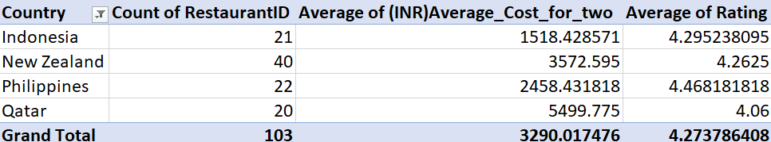
- Reference : In the sheet named “Descriptive Data”

- Visualize trends using a Clustered Column Chart :
  - Count of restaurants (competition)
  - Average rating (quality perception)

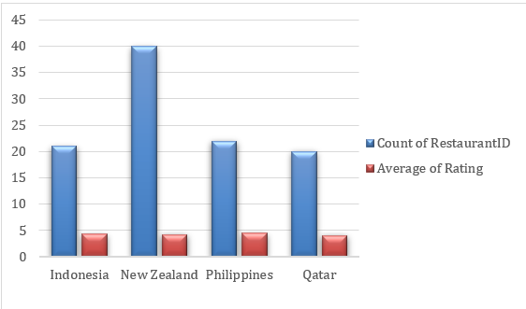

Q2. Come up with the names of States and cities in the suggested countries suitable for opening restaurants.?
- Objective of this question is to identify the most suitable cities within the suggested countries (Indonesia, Philippines, New Zealand, Turkey) for opening new restaurants, based on market potential, customer satisfaction, and pricing trends.
Data Used:
Pivot table summarizing city-wise metrics:
- City
- Count of Restaurants
- Average Rating
- Average Price for Two (INR)
Pivot Table Data:
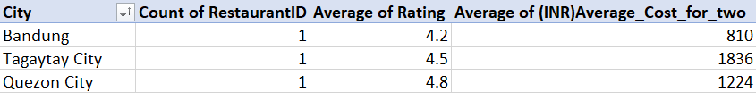
Analysis:
- Bandung (Indonesia): Very less restaurant presence (here only 1) , good rating (4.2), and low average cost (₹810). Great opportunity for the restaurants with the affordable price range and good quality food.

- Tagaytay City (Philippines): Very less restaurant presence (here also only 1) good rating (4.5), and average price (₹1,836) a little bit towards the premium range. Suitable for high -range pricing strategies, may be with high margins.
- Quezon City (Philippines): Small market size (1 restaurant), very high rating (4.8), and mid-range average cost (₹1,224). Indicates strong customer preference and opportunity for quality-focused restaurants.
Approach:
- Criteria used for selecting the city was same as the criteria used in selecting the countries low competition, high-Rating and a good price range with good margins.
- Use Pivot Tables to monitor city-wise trends across all suggested countries.
- Visualize city-level metrics using Bar Charts or Clustered Column Charts:
  - Count of restaurants (market saturation)
  - Average rating (quality perception)
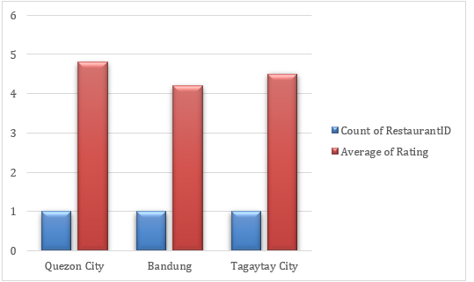

Q3. According to the countries you suggested, what is the current quality regarding ratings for restaurants that are open there?
- Approach: Used the data of average rating of the countries suggested by me :

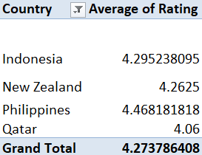
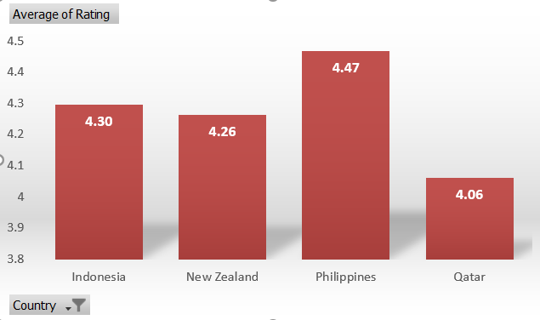
- Insights and recommendations:
Country-Specific Quality Breakdown
- The Philippines (Highest Quality): With an average rating of 4.47, the Philippines currently offers the highest perceived quality among my selections. This indicates a market where consumers are exceptionally satisfied with their dining experiences, setting a high benchmark for any new entrant.

- Indonesia (Strong Consistency): Indonesia holds a solid 4.30 rating. This reflects a high level of consistent quality, especially impressive given that it has the lowest average cost (₹1,518.74) among others, suggesting excellent "value for money" in the eyes of the consumer.

- New Zealand (Proven Quality at Scale): New Zealand maintains a strong 4.26 rating across the largest number of restaurants (40). This demonstrates that high quality is being maintained even as the market scales, indicating a mature and reliable culinary infrastructure.

- Qatar (Premium Standard): Although Qatar has the lowest rating of the group (4.06), it is still above the "good" threshold. However, considering it has the highest average cost (₹5,499.75), there is a slight "quality-to-price" gap compared to the other nations, suggesting that while the food is good, the expectations for the price paid are extremely high.

Q4. Current expenditure on food in suggested countries:
- Objective:
For finding the current expenditure on food in suggested countries we will be using the “Average Cost For Two (INR)” for estimating.
Pivot Table Data (Average Price for Two in INR):
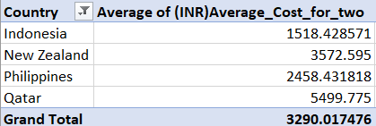
Analysis and Insights :
1) . Qatar: The Luxury Tier
- Average Cost: ₹5,499.75
- Analysis: Qatar is significantly more expensive than the other three countries—nearly 4x the cost of Indonesia. This high entry price suggests a market dominated by premium dining and high-end ingredients, where consumers have high purchasing power but also expect top-tier luxury for the price paid.
2). New Zealand: The Mid-High Tier
- Average Cost: ₹3,572.59
- Analysis: New Zealand sits in the upper-middle price bracket. As it has the highest number of restaurants (40), this price likely represents a stable, western-standard casual dining market. It is a mature market where people are accustomed to paying a moderate premium for quality.
3). Philippines: The Emerging Growth Tier
- Average Cost: ₹2,458.43
- Analysis: The Philippines offers a strategic "middle ground." It is roughly half the price of Qatar but provides the highest satisfaction (4.47 rating). This suggests a very healthy market where people are willing to spend reasonably, and the quality delivered exceeds the cost.
4). Indonesia: The Mass Market Tier
- Average Cost: ₹1,518.74
- Analysis: Indonesia is the most affordable country on your list. This low cost-of-entry is ideal for high-volume, mass-market expansion. It shows that quality dining is highly accessible here, making it the most competitive location for price-sensitive consumers.

Approach:
- Use Pivot Tables to summarize average price for two in each country.
- Visualize using a Bar Chart or Column Chart to compare average expenditure across countries.
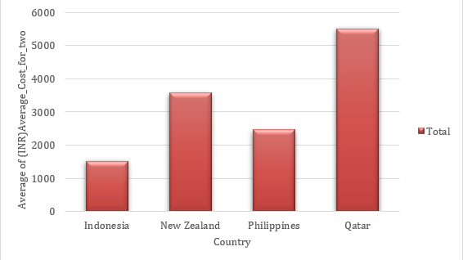

Q5. Come up with the names of restaurants from the recommended states that are our biggest competitors and also those that are rated in the lower brackets, i.e. 1-2 or 2-3.?
- Objective:
To identify key competitors and potential low-performing restaurants in the recommended locations. This helps in understanding the competitive landscape and market positioning for new restaurants.
Pivot Table Data:
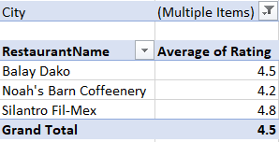

Analysis:
As the cities we have taken only have one restaurant , so our competition is only to those restaurants .
Also, there are no restaurants that are rated in the lower brackets, i.e., 1-2 or 2-3., all our competitors having a good rating (>4)
Insights & Recommendations:
As, the competitors are having a good rating, the new entrants should enter with something new and different and innovative. Introduce innovative menu items or customer experience improvements to gain a competitive edge. Since, there are no low-rated restaurants, the market quality is high — new entrants should maintain high standards to succeed.
Q6. Which cuisines should we focus on in the newer restaurants to get better feedback? Does the choice of cuisines affect the restaurant ratings?

- Objective: To identify the cuisines that are most demanding and are being served in maximum numbers of restaurants .
Top Cuisines (Number of Restaurant by Cuisines):
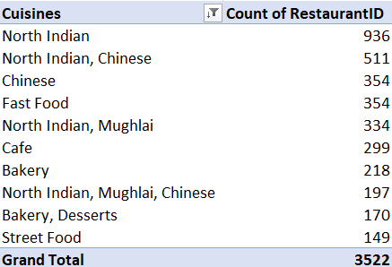

Analysis:
- Certain cuisines have a higher number of restaurants, indicating strong market demand and customer interest.
- This suggests that some cuisines are more popular and widely accepted in the market.

Approach:
- Focus on cuisines with high restaurant counts when launching new outlets.
- Consider blending popular cuisines with unique or localized menu items to stand out.
- Use pivot tables and bar charts to track which cuisines are expanding and maintain real-time insights.
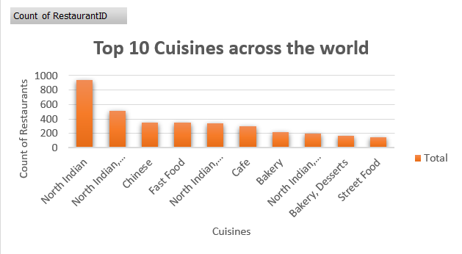

Insights:
- High presence of certain cuisines indicates market viability, not necessarily quality.
- New restaurants should balance popularity with differentiation to gain a competitive edge.

Q7. According to our current data, should we go for online delivery and table booking? Does that affect the customer’s ratings?
Objective:
To analyze whether offering online delivery or table booking has a significant impact on restaurant ratings. This informs operational strategies for new restaurants.
Pivot Table Data:
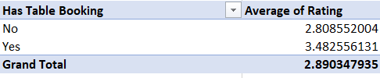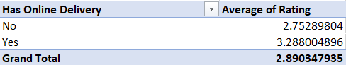

Analysis:
- Restaurants offering online delivery have a higher average rating (3.29) compared to those that do not (2.75).
- Restaurants that allow table booking have an even higher average rating (3.48) versus those that do not (2.81).
- This indicates that providing convenience services like online ordering and table reservation positively affects customer satisfaction.
Insights & Recommendations:
- Implement online delivery for new restaurants to improve accessibility and attract more customers.
- Enable table booking options to enhance customer convenience and service quality.
- Marketing campaigns highlighting these services can further boost customer satisfaction and engagement.
- Use pivot tables and charts to continuously monitor the impact of these services on ratings.
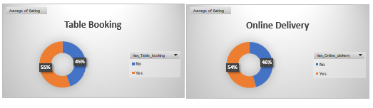

Q8. Should the team keep the rate of cuisines higher? Will that affect the feedback? According to our data are the rates of cuisines and ratings, correlated?
- Approach : Analysing of Correlation Between Cuisine Average_cost_of_two(INR) and Customer Ratings, which will tells us if there any relation between the Rate of cuisines and ratings from which we can find out and setup the prices for the cuisines for new restaurants accordingly.
- 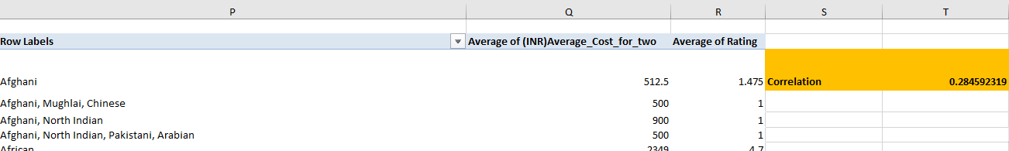

- Formula Used for Correlation : =CORREL(Q3:Q1827,R3:R1827)

- Insights:
The correlation coefficient between the Average rating and the Average_cost_for_two(INR) of cuisines is (0.285). This value indicates a very weak positive correlation. In practical terms, it suggests that higher-priced cuisines are only slightly associated with higher customer ratings, but the relationship is not strong or significant.

- Recommendation and Conclusion:
Based on the current data, the team does not need to prioritize increasing cuisine rates as a means to improve customer feedback. Efforts should instead target quality enhancement and customer experience improvements, which are more likely to influence ratings positively.

Q9. What is the distribution of the number of restaurants of different price ranges in all the countries?
- Distribution of Restaurants by Price Range Across All Countries
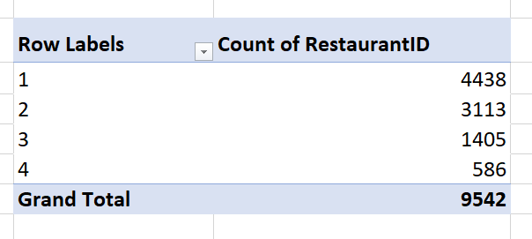
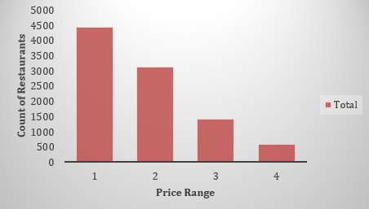
Analysis:
- Mass Market Focus: Price Range 1 is the most dominant, with 4,438 restaurants, showing the market is driven by affordability.

- Declining Volume: As the price range increases, the number of restaurants consistently decreases, forming a pyramid-shaped distribution.

- Significant Drop-off: There is a sharp decline between Range 2 (3,113) and Range 3 (1,405), where the count more than halves.

- Niche Luxury: Price Range 4 is the smallest segment with only 586 restaurants, indicating that high-end dining is a very exclusive niche.

- Majority Share: Nearly 79% of all restaurants fall into the lower two price ranges (1 and 2), representing the bulk of the industry.

Q10. Explain your approach in brief for suggesting countries/cities in order to open new restaurants, if the objective and subjective questions would have not been given to assist you. [you have to give bullet pointers in order to answer this question]?
- Identifying the countries with the low competition.
- Analyze the crowd/population of the countries which can help us in understanding the demand of restaurants.
- Analyze the cuisines for different cities and countries, like in which country which cuisine is most selling and demanding.
- Analyzing the price trends of the restaurants for the countries and cities and then accordingly setting up the prices of the new restaurants.
- Analyzing the need of online delivery and table booking for the particular region or the country.

- Using the basic to advance excel formulas and pivot table and visualization for easy analytics.

